# Download image Raspbian

* Go to this page to download the Raspbian Jessie

<https://www.raspberrypi.org/downloads/raspbian/>

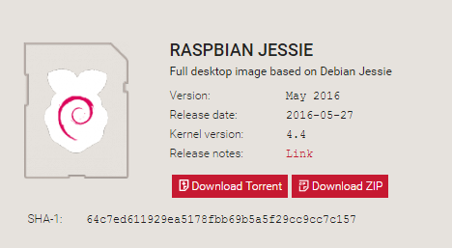

# Download WinFlashTool or Win32DiskImager-0.9.5-install

# Install

* Open WinFlashTool
* Step 1: Choose an image that you have downloaded in Section 1
* Step 2: Check on an checkbox “Resize … “
* Step 3: Click Write , then choose the partition you want to drive and then continue clicking on “Erase And”
* Step 4: Wait for 10 minutes , if an error is occurred , you just need to click “Write” again
* Good luck ☺